Third Grade News
Dec. 18-21, 2017

IMPORTANT DATES -
December
18-19 – Penguin Patch holiday shop will be open. Items range from .25- $12.00
15 – Party items were due
20 – Last day to send donations for nursing home
20 -3rd Grade Lunch is at 11:30
20 –Pajama Day
20 –Watching Arthur Christmas – rated PG
21 – Party @ 1:30-2:00
Dec. 22-Jan. 5 – Christmas Holidays
January –
8-Students Return

Our learning Targets
for the week –

Math –Multiplication & Division
ELA – You Wouldn’t Want to Sail with Christopher Columbus!
Science – Heat
Social Studies – Explorers

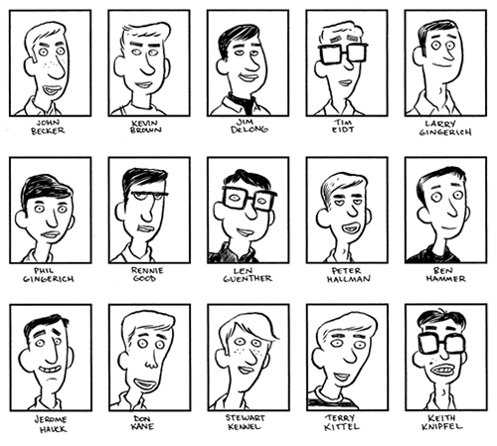

BUY A YEARBOOK
for $30 until Christmas.
After Christmas, they’ll be $35.
Keyboarding Practice websites!!!
http://www.bbc.co.uk/guides/z3c6tfr
http://www.typinggames.zone/typetastic
https://www.typing.com/typinggames

PLEASE send books for book exchange before the 21st. We will do our exchange the morning of the 21st, not during the party.

Our recess is at 10:15 each morning. It’s still pretty cold at that time of day. Several students have not had jackets. Please send your child with a jacket for recess. Thanks!!

On Twitter??? Follow us @HillCityHawks

Hill City is fortunate to have a wonderful and supportive PTO.
They have many new and exciting activities
planned for our families this year.
Please consider joining with a $5.00 donation per family.
Thanks for your support!

Teacher Webpage Links
Type into URL and don’t forget to save to your desktop/favorites.

http://hcesmrsmossbuckaroos.weebly.com/
http://hcesmrsmosley.weebly.com/
https://mrsgaddisgang.shutterfly.com/
http://hcesmrschilders.weebly.com/
HCES Vision Statement:
Graduation and life preparation for all.
http://hcesmrslongsclass.weebly.com/

Suggested Websites
www.commoncoresheets.com (print out sheets to complete)
www.raz-kids.com (stories to read)
www.ixl.com (math practice)
www.xtramath.org (great place to study addition facts)
www.kidrex.org (kid friendly search engine)
www.lexile.com (see appropriated level books for your reader)
www.storylineonline.net (listen to stories)
www.readworks.org (print stories with questions for comprehension)
www.kids.nationalgeographic.com

Questions? Concerns?
amychilders@pickenscountyschools.org
pamlong@pickenscountyschools.org
deannamosley@pickenscountyschools.org
kellymoss@pickenscountyschools.org
brittanygaddis@pickenscountyschools.org

